**TITTLE: ILLUSTRATION OF THE CAR ANIMATION USING MACROMEDIA FLASH.**

**CONCEPT**

In this car animation, we use two cars and a background image in different layer. We insert images in key frame and create motion tween to make the effect of movement. We select motion in tween, we change the position of cars in different key frame. In this way we can animate the car in macromedia flash.

**PROCEDURE**

**Step 1:**

Open a new document to work & adjust the stage size of document according to need.

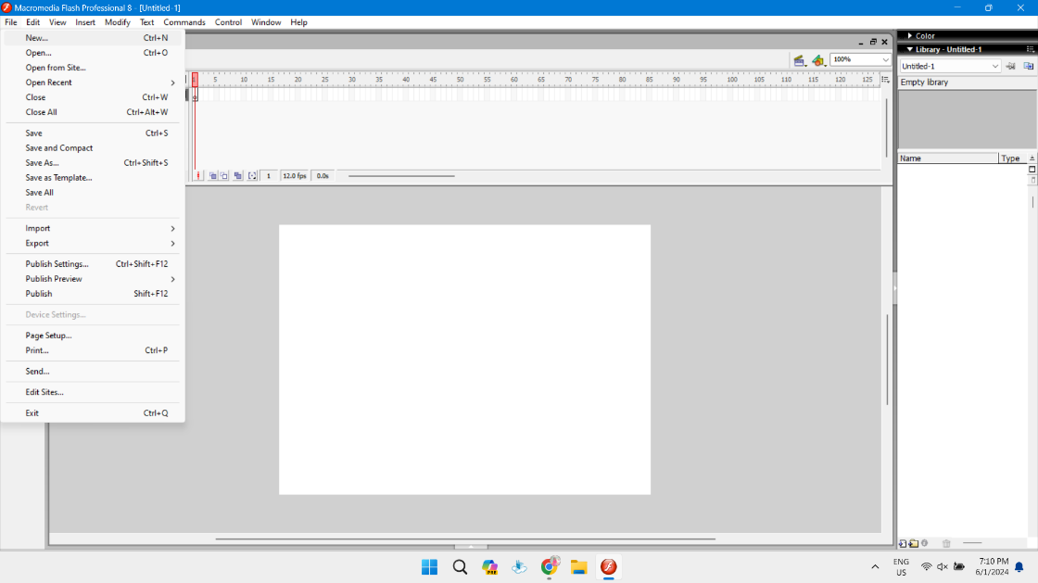

**Step 2:**

Import images from the computer. Click on File then click on import to stage and import images of background image on the first frame of layer 1 and named it as ‘background'. Adjust the size of image using free transform.

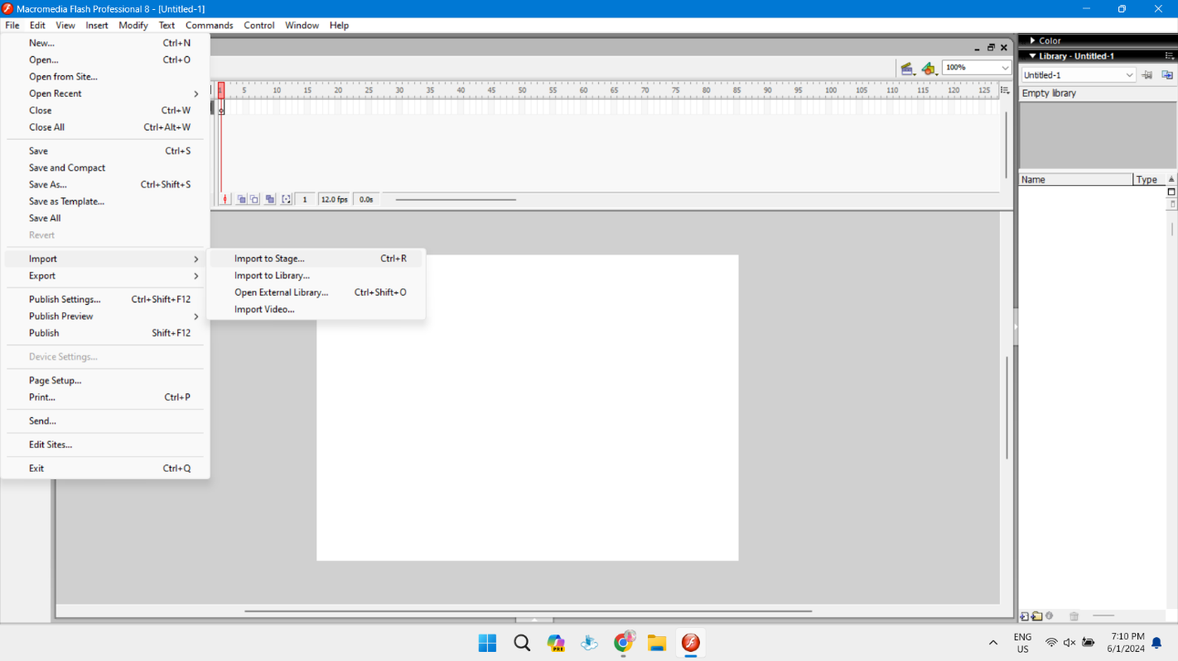 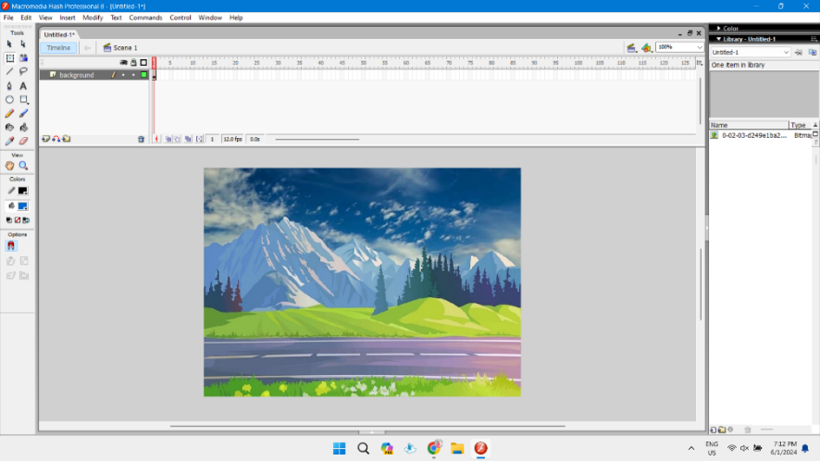

**Step 3:**

Similarly on the first frame of layer 2 and layer 3 named as car1 and car2, drag the image of cars from the library to the stage in given position as shown in figure below. Adjust the size of images using free transform.

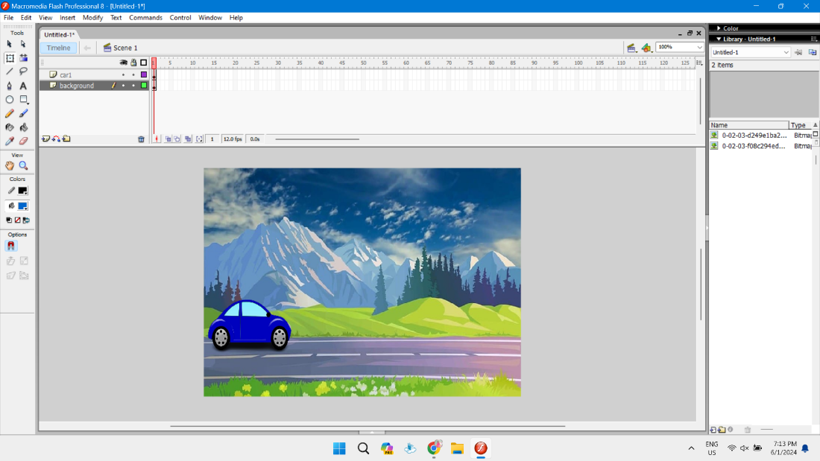 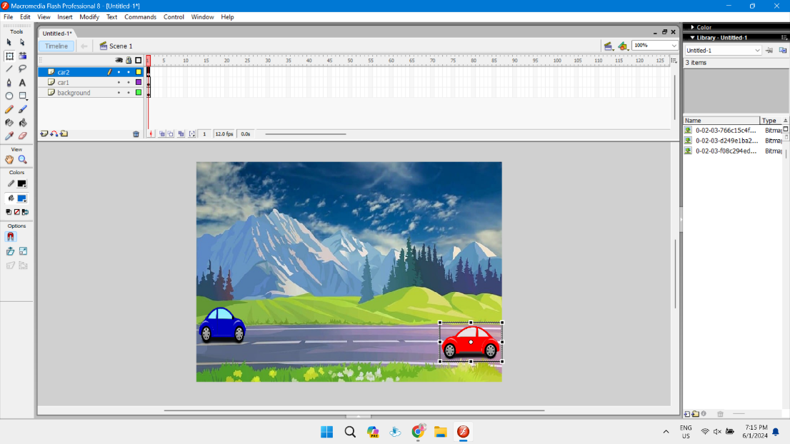

**Step 4:**

Insert the key frame on 70th frame of each layer. Click on car 1 and car 2 and change the position of cars as shown in figure below.

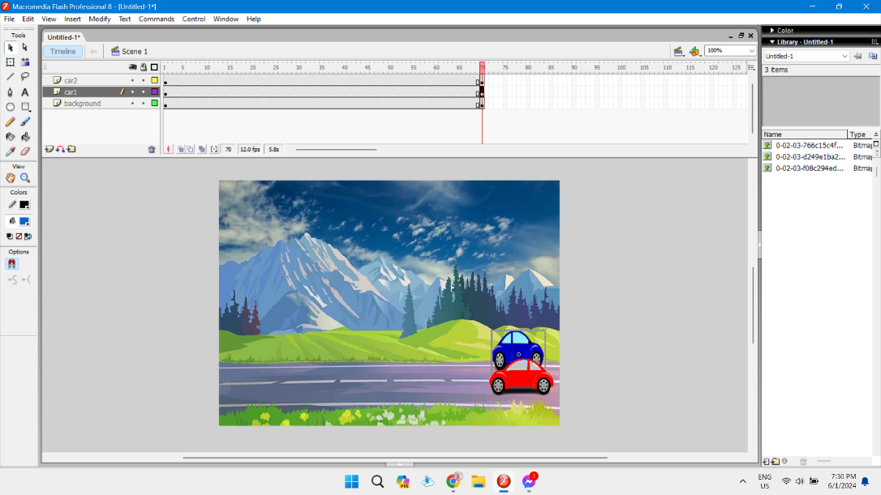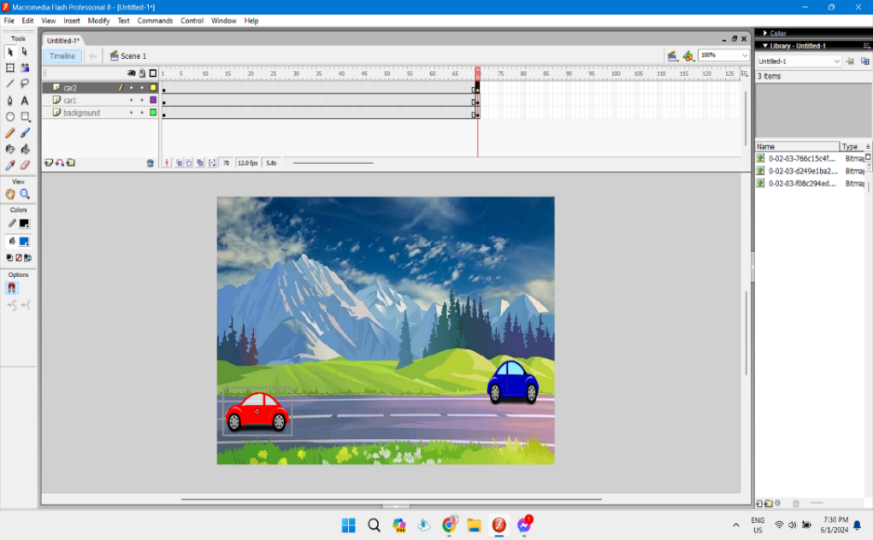

**Step 5:**

Click on any key frame of layer car 1 and car 2 and click on create motion tween.

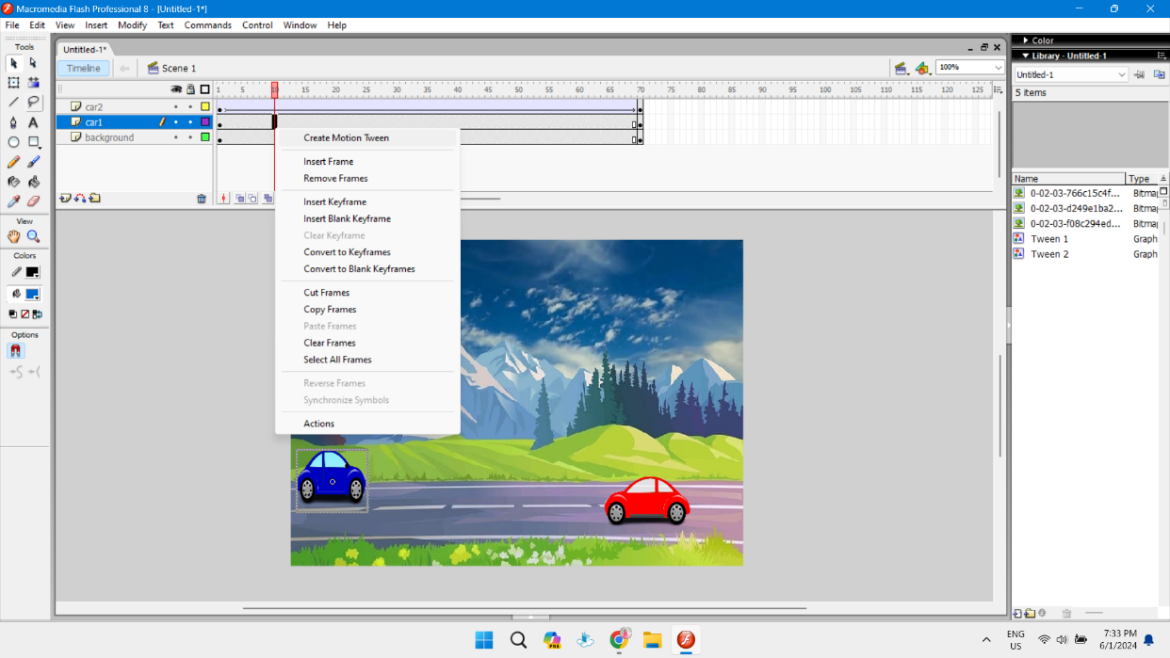

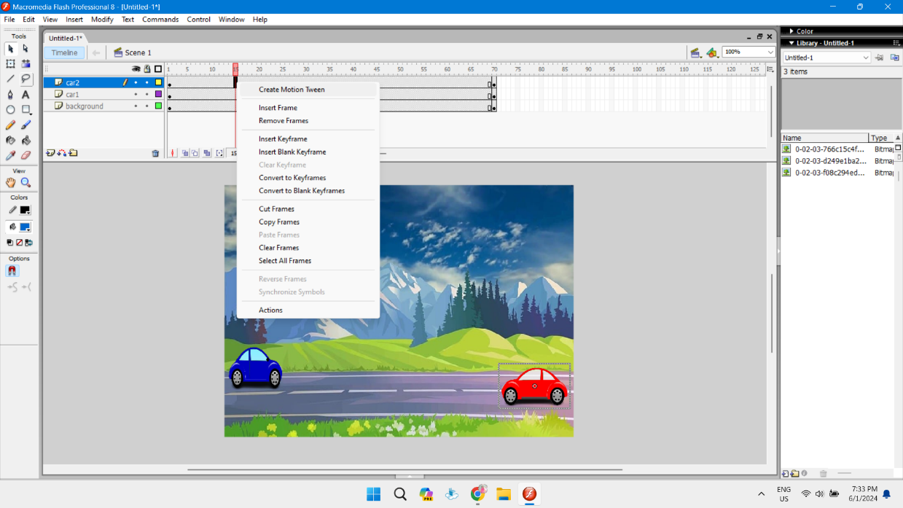

**Step 6:**

Again, on the first frame of layer 4 and layer 5 named as play and stop, drag the image for play button and stop button from the library to the stage in given position as shown in figure below. Add text on the image for the identification of play and stop button. Adjust the size of images using free transform.

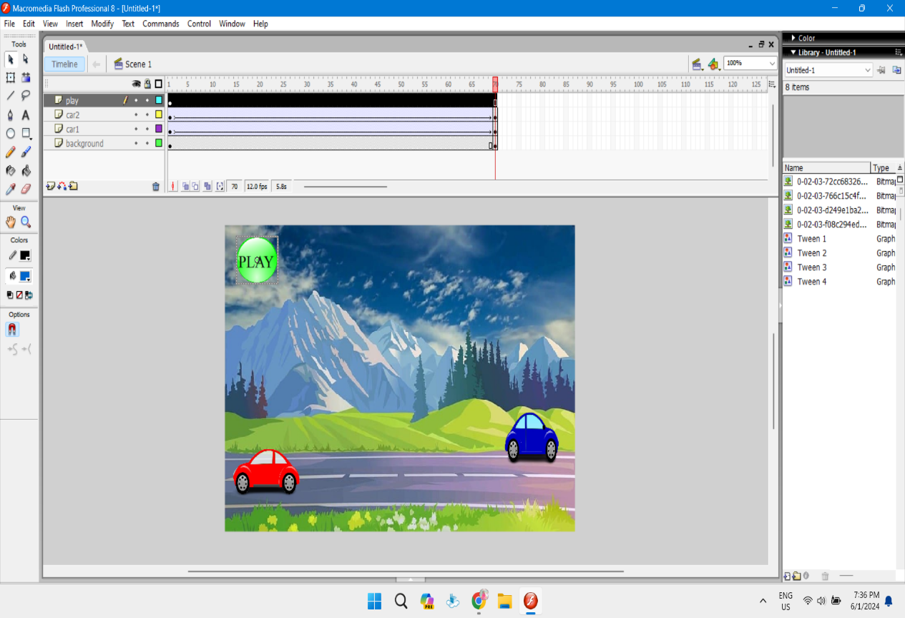 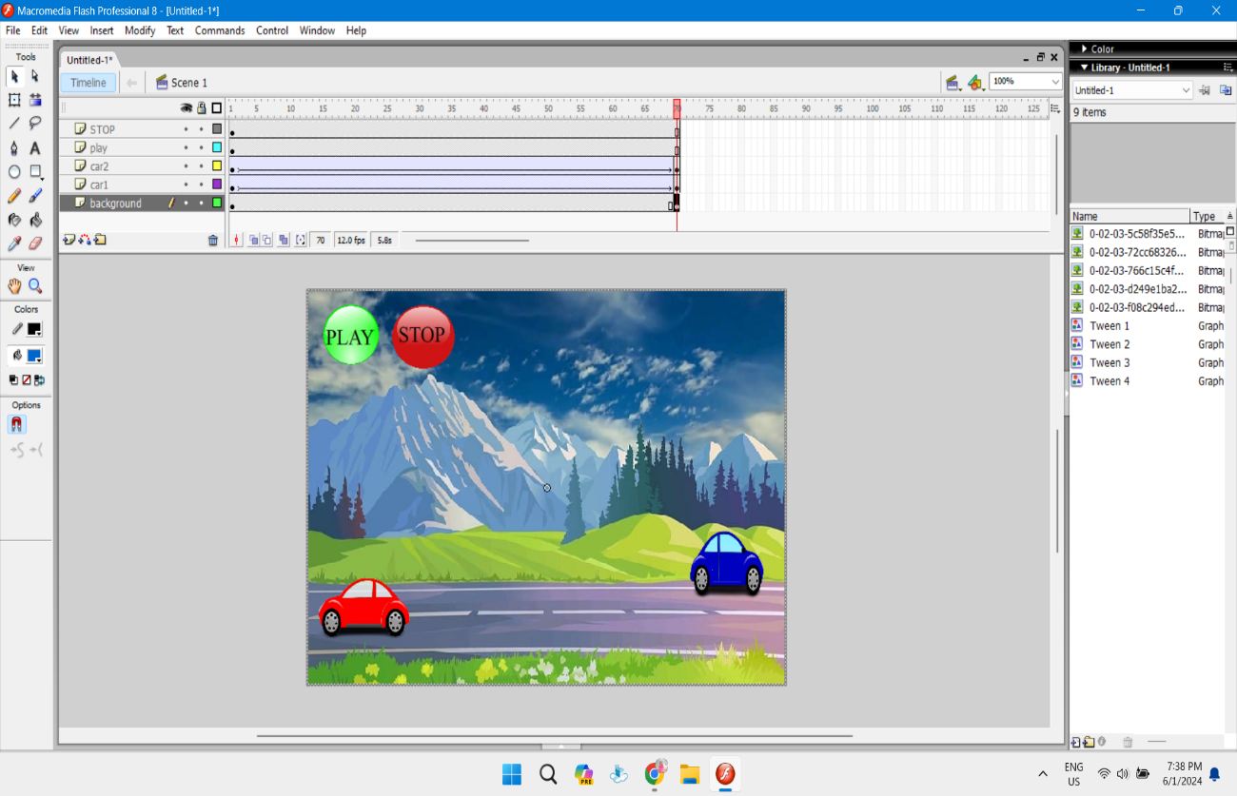

**Step 8:**

Click on the image of play button and press F8 to open to convert it into symbol. Similarly click on the image of stop button and press F8.

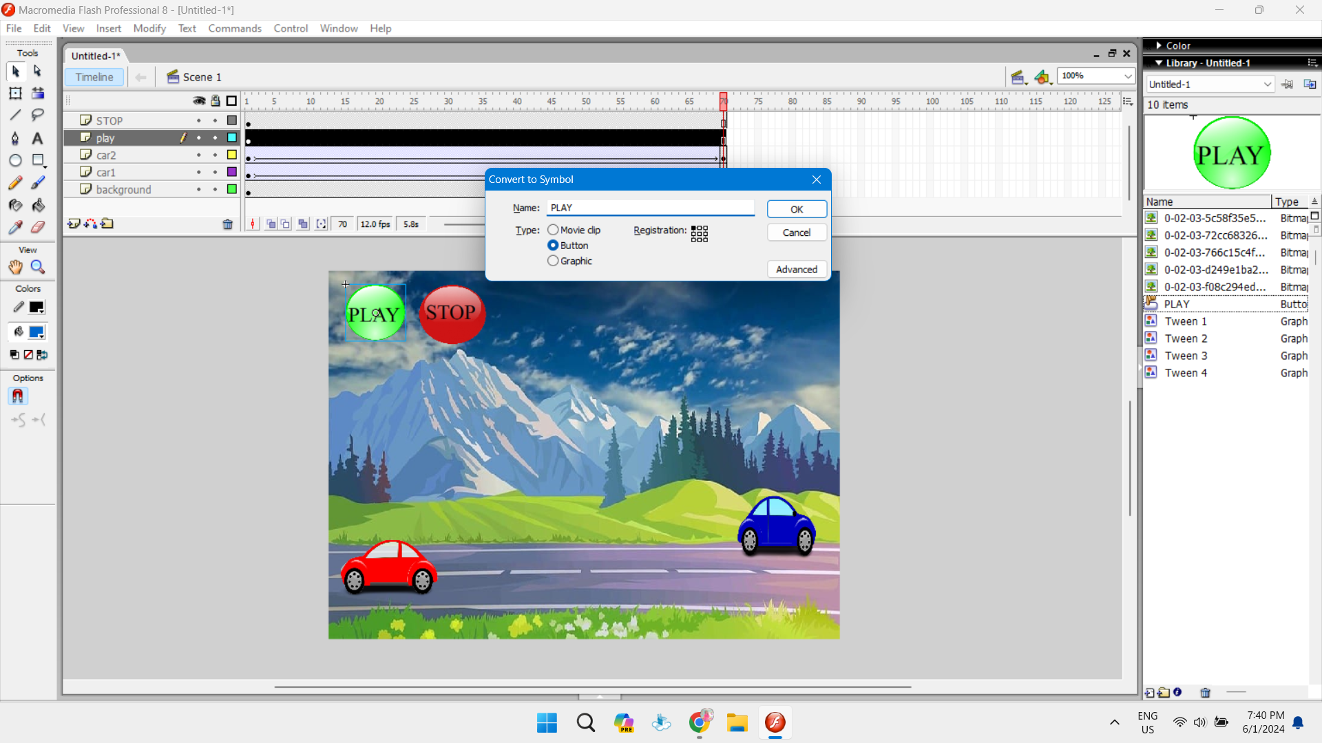

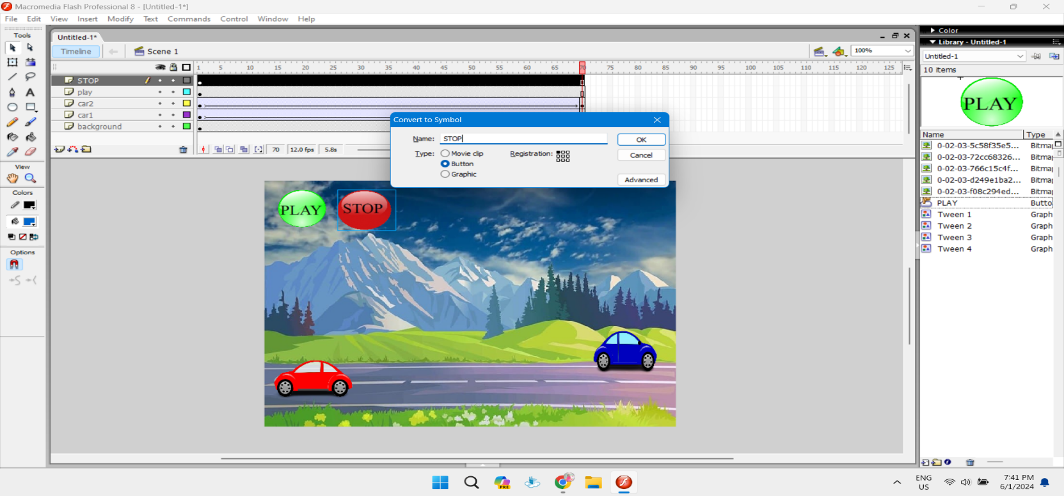

**Step 9:**

Right click on green button, click on Action and write the function for play as shown below and also check for errors.

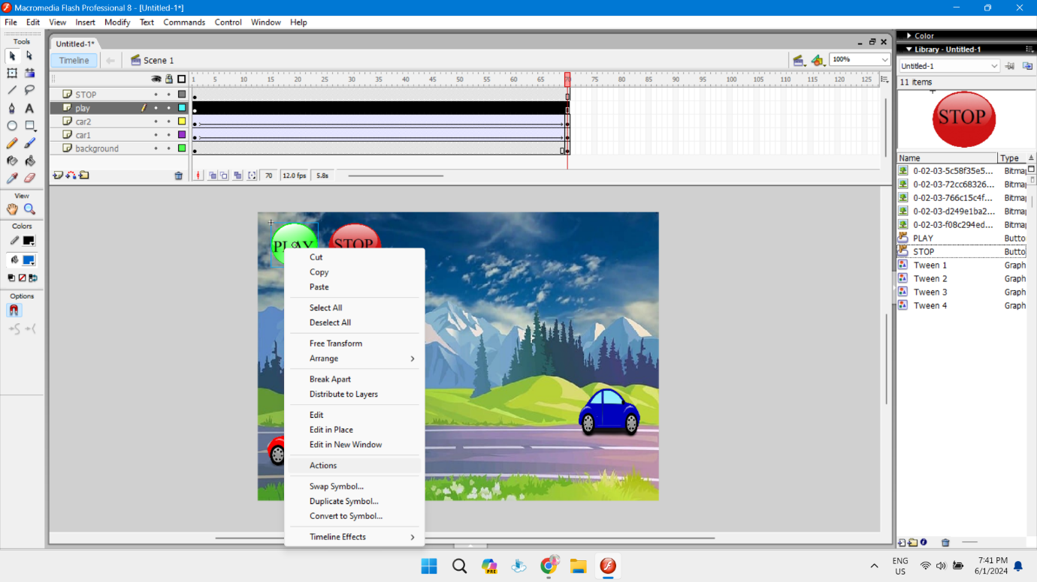 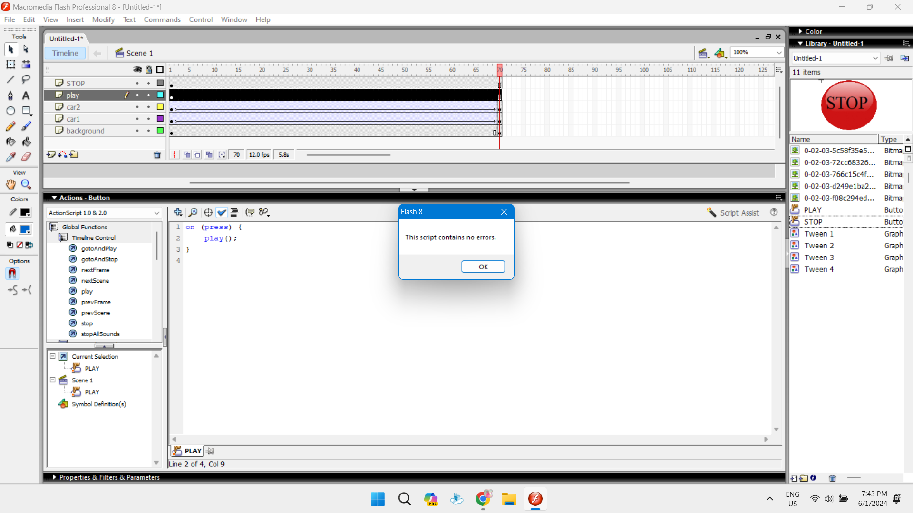

**Step 10:**

Similarly, right click on red button, click on Action and write the function for stop as shown below and also check for the errors.

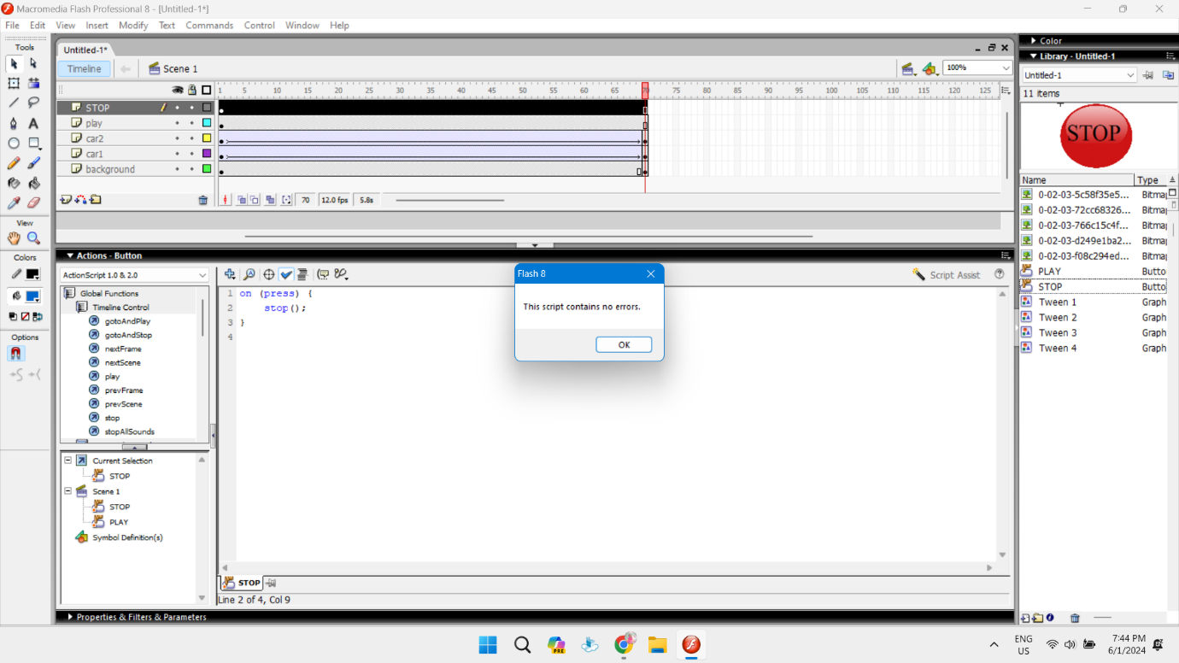

**OUTPUT**

The position of car changes and buttons are working properly as shown below.

1. The position of car at first image

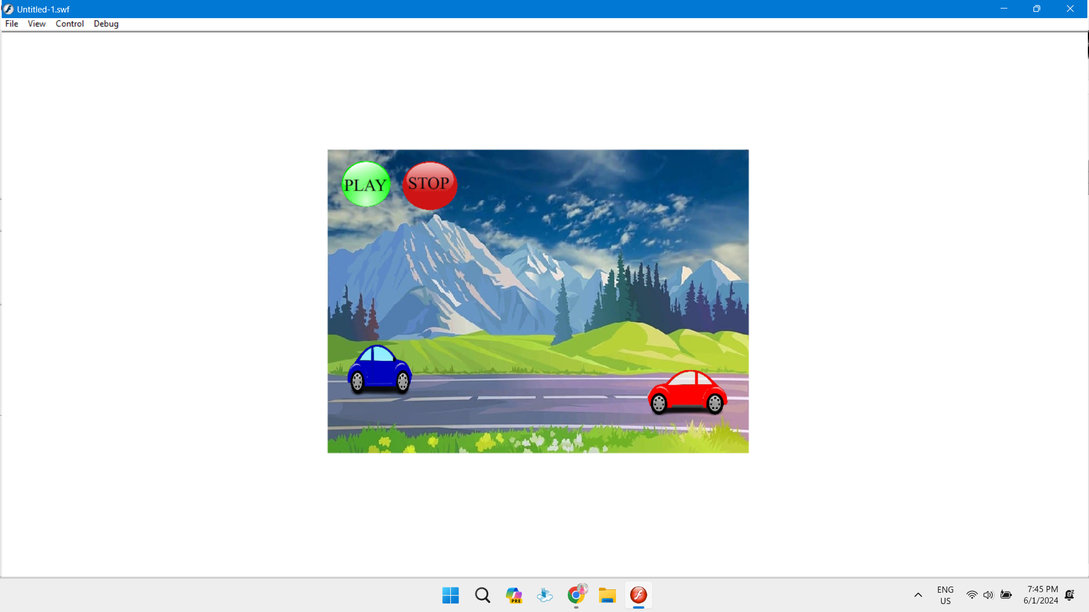

1. The position of car at second image

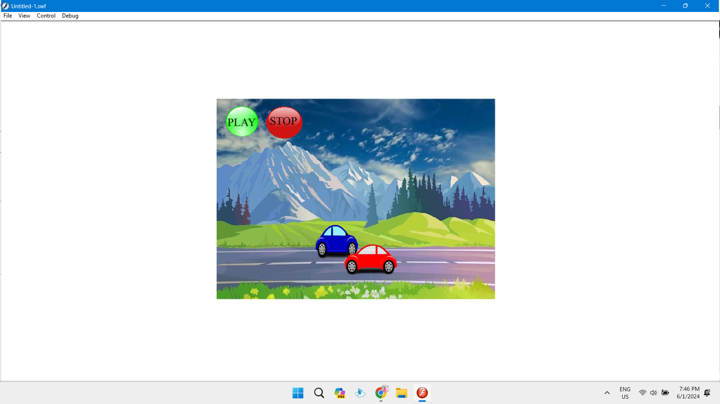

1. The position of car at third image

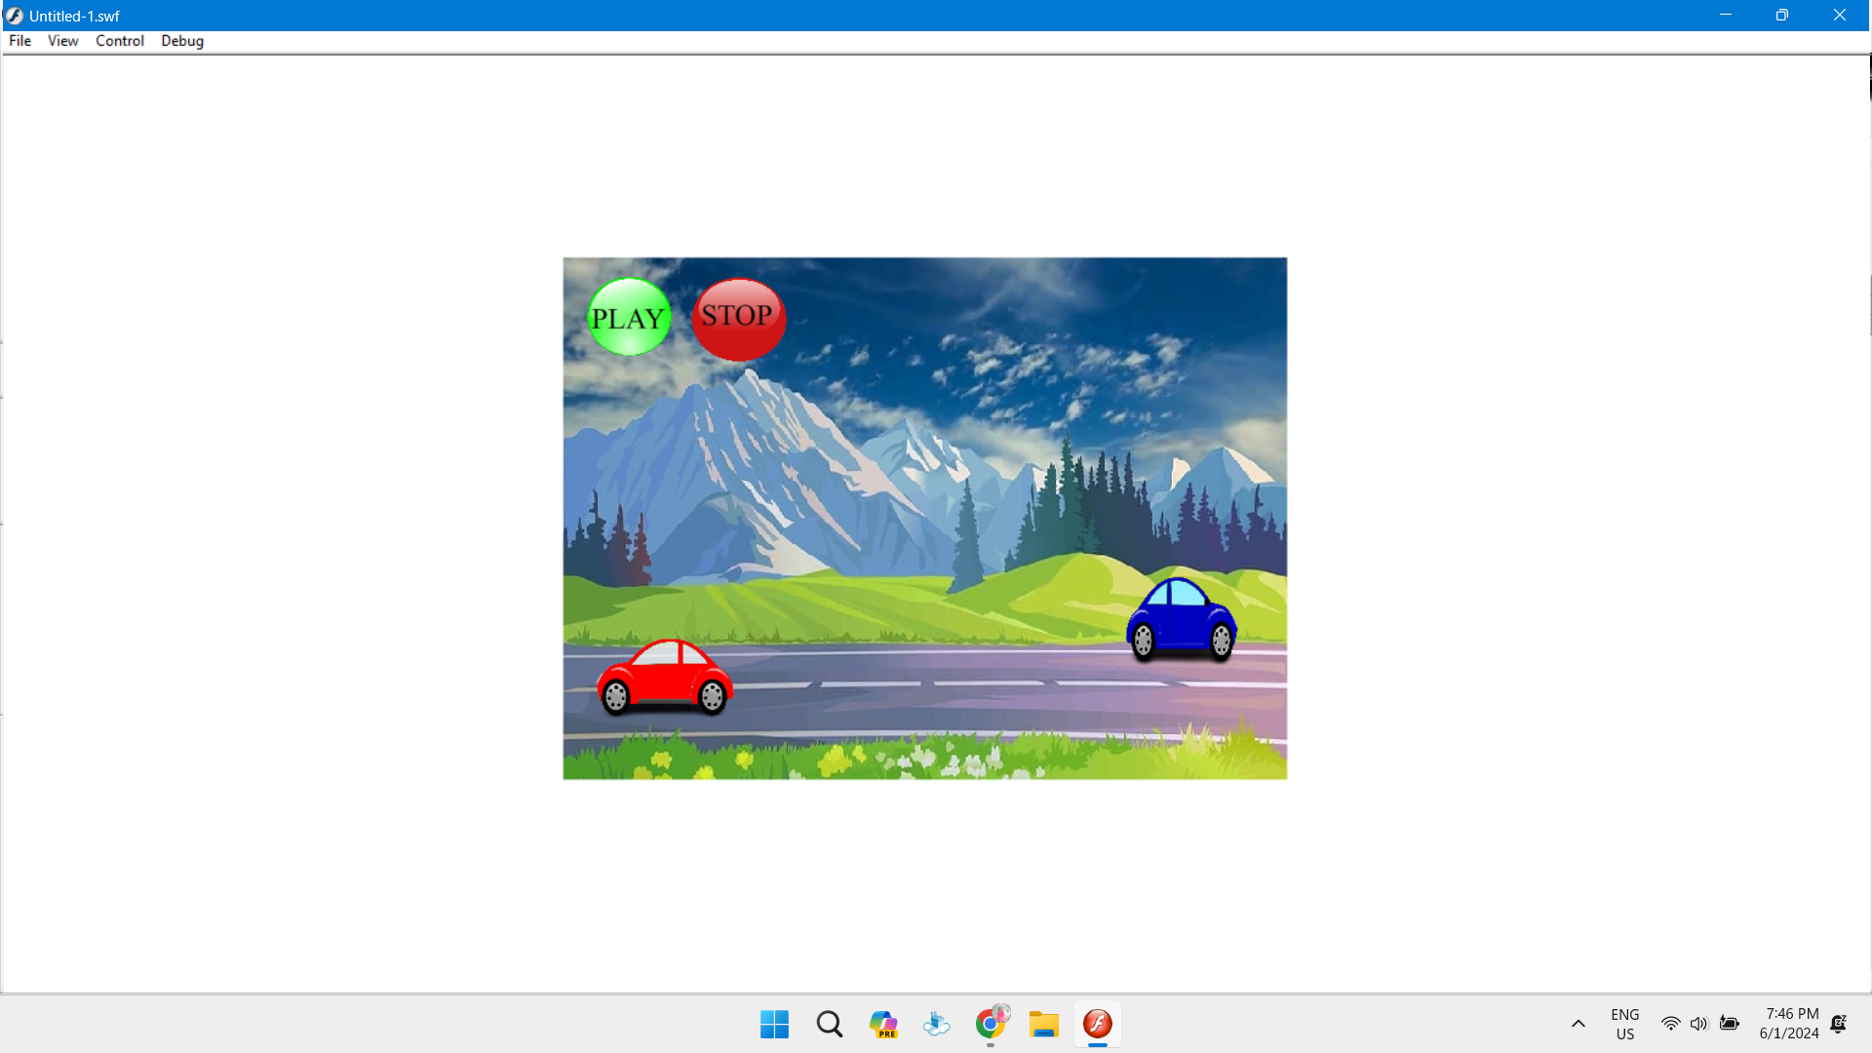

**CONCLUSION**

From the above experiment, we concluded that we can animate the car using play button and stop the car using stop button.